**Ideation Phase**

**Define the Problem Statements**

|  |  |
| --- | --- |
| Date | 19 September 2022 |
| Team ID | PNT2022TMID45319 |
| Project Name | Smart Fashion Recommender Application |
| Maximum Marks | 2 Marks |

**Customer Problem Statement Template:**

Create a problem statement to understand your customer's point of view. The Customer Problem Statement template helps you focus on what matters to create experiences people will love.

A well-articulated customer problem statement allows you and your team to find the ideal solution for the challenges your customers face. Throughout the process, you’ll also be able to empathize with your customers, which helps you better understand how they perceive your product or service.

Reference: https://miro.com/app/board/uXjVPHG74wA=/?share_link_id=437592675885

**Example:**

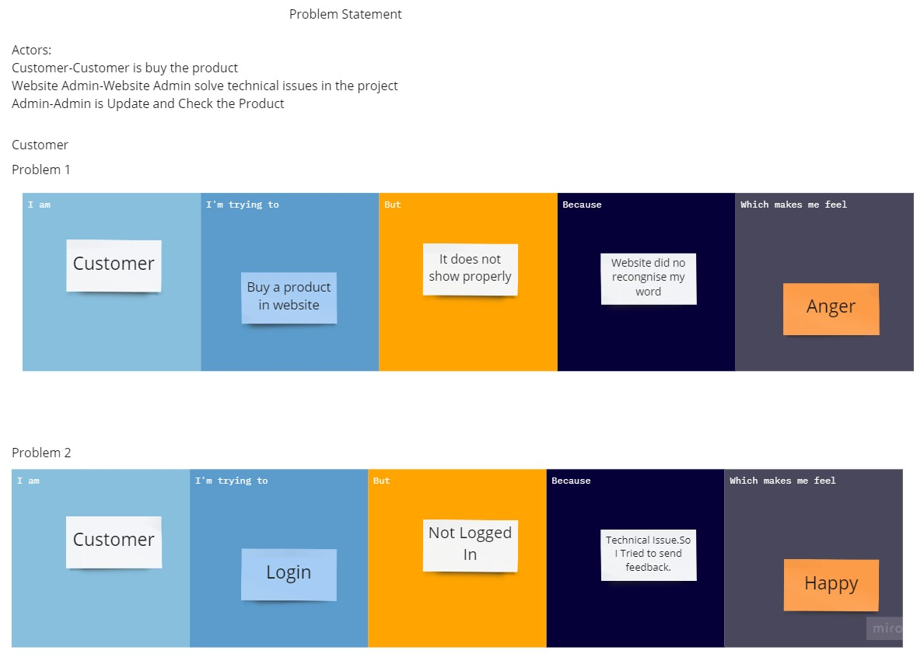

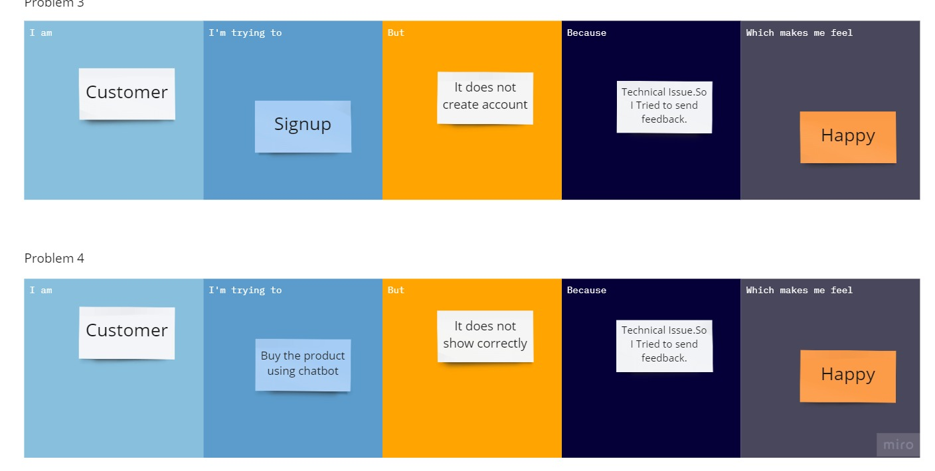

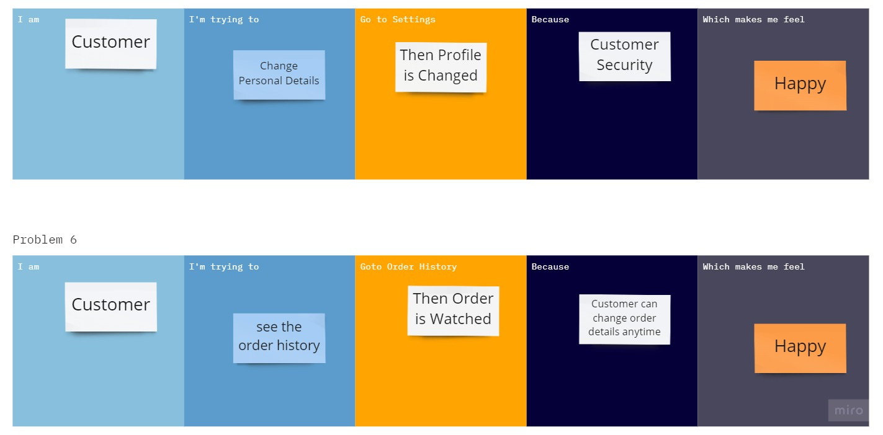

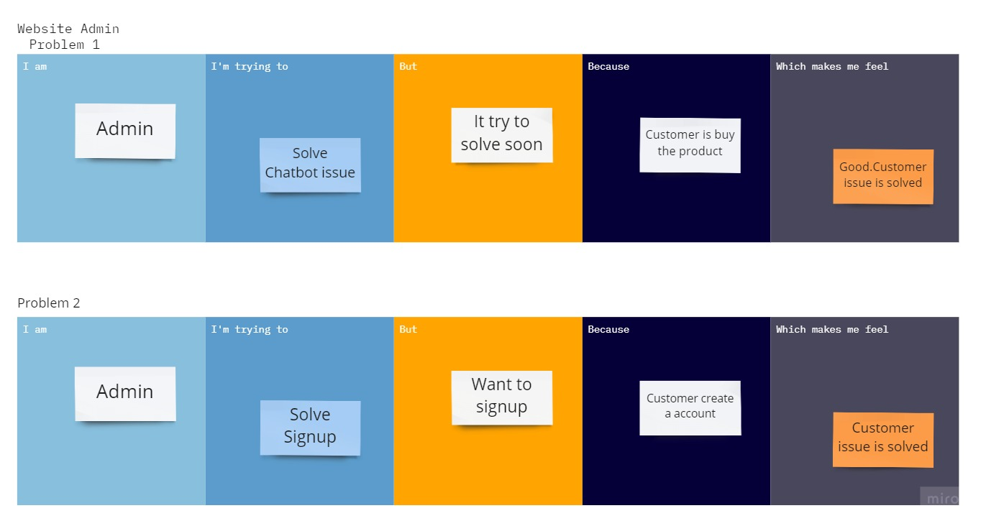

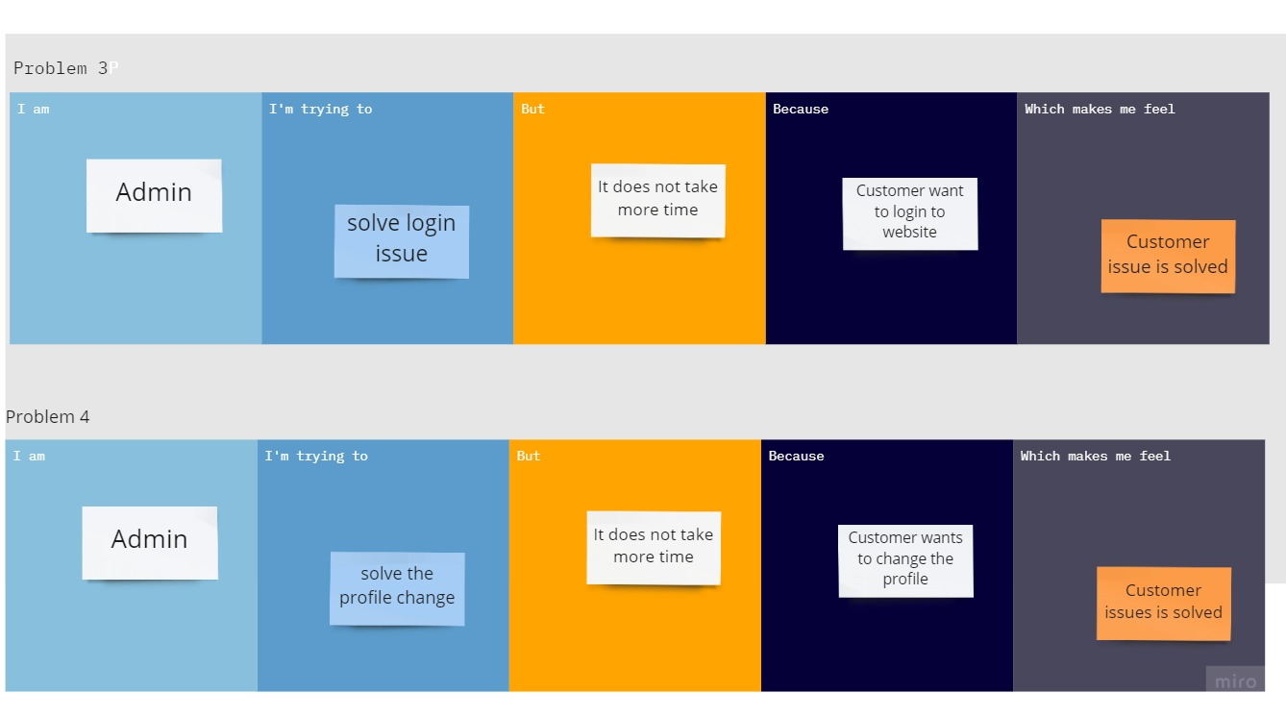

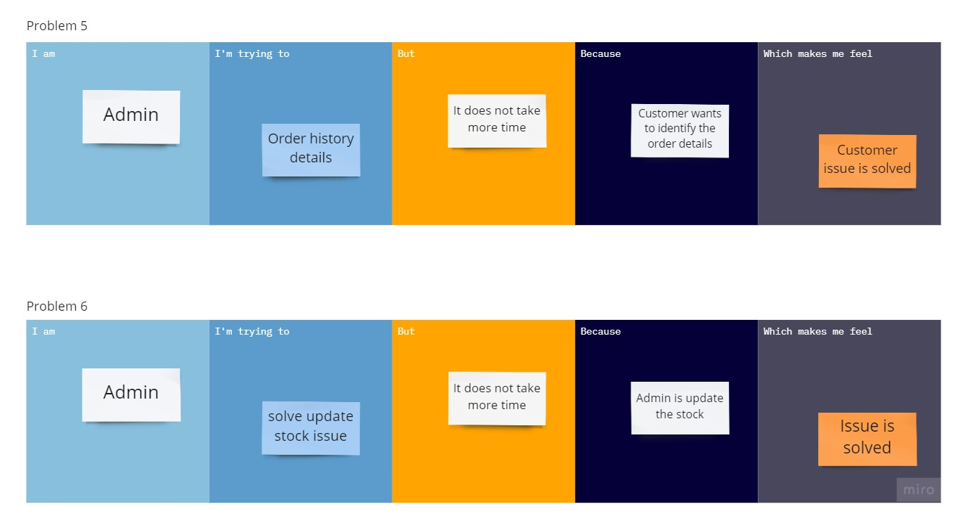

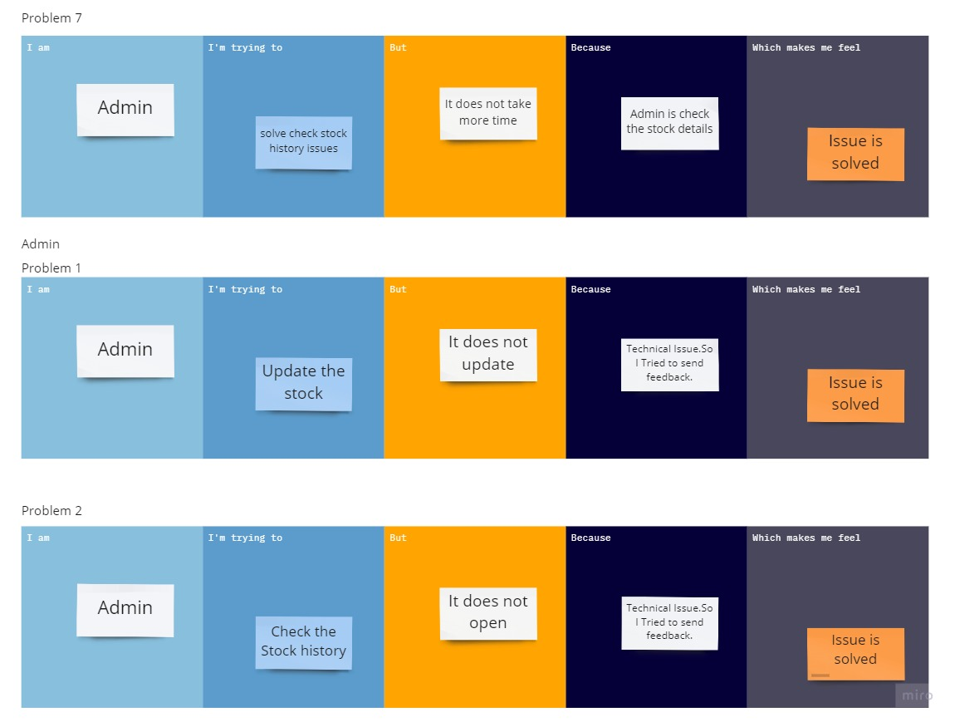

|  |  |  |  |  |  |
| --- | --- | --- | --- | --- | --- |
| **Problem Statement (PS** | **I am (Customer)** | **I’m trying to** | **But** | **Because** | **Which makes me feel** |
| PS-1 | Customer | Buy a product in website | It does not show properly | Website did no recognise my word | Anger |
| PS-2 | Customer | Login | Not logged in | Technical issue.so I tried to send feedback. | Happy |
| PS-3 | Customer | Signup | It does not create account | Technical issue.so I tried to send feedback. | Happy |
| PS-4 | Customer | Buy the product using chatbox | It does not show correctly | Technical issue.so I tried to send feedback. | Happy |
| PS-5 | Customer | Change personal details | Then profile is changed | Customer security | Happy |
| PS-6 | Customer | See the order history | Then order is watched | Customer can change order details anytime | Happy |
| PS-7 | Admin | Solve chatbox issue | It try to solve soon | Customer is buy the product | Good customer issue is solved |
| PS-8 | Admin | Solve signup | I Wants to signup | Customer create a account | Customer issue is solved |
| PS-9 | Admin | Solve login issue | It does not take more time | Customer want to login to website | Customer issue is solved |
| PS-10 | Admin | Solve the profile change | Id does not take more time | Customer wants to change the profile | Customer issue is solved |
| PS-11 | Admin | Order history details | It does not take more time | Customer wants to identify the order details | Customer issue is solved |
| PS-12 | Admin | Solve update stock issue | It does not take more time | Admin is update the stock | Issue is solved |
| PS-13 | Admin | Solve check stock history issues | It does not take more time | Admin is check the stock details | Issue is solved |
| PS-14 | Admin | Update the stock | It does not update | Technical issue. So I tried to send feedback. | Issue is solved |
| PS-15 | Admin | Check the stock history | It does not open | Technical issue. So I tried to send feedback. | Issue is solved |